1. Introduction
1.1 Purpose:
The objective of Student information System is to allow the administrator of any organization to edit and find out the personal details of a student and allows the student to keep up to date his profile .It’ll also facilitate keeping all the records of students, such as their id, name, mailing address, phone number, DOB etc. So all the information about an student will be available in a few seconds.
Overall, it’ll make Student Information Management an easier job for the administrator and the student of any organization.
The main purpose of this SRS document is to illustrate the requirements of the project Student information System and is intended to help any organization to maintain and manage its student’s personal data.

1.2 Scope :

Without a Student information System, managing and maintaining the details of the student is a tedious job for any organization.
Student Information system will store all the details of the students
including their background information, educational qualifications, personal details and all the information related to their resume .

Login module: Login module will help in authentication of user accounts .Users who have valid login id and password can only login into their respective accounts.

Search module: Suppose there are hundreds of students and from this we have to search a particular student and we know the Roll Number of the student .In manual system it is a tedious task though we know the Roll Number of the student, but using this module we can easily search the student by specifying the Roll Number of the student in the search criteria. Thus this module will help the administrator in searching the student with various criteria easily.

User Management: This module will help the administrator in enabling/disabling a user account and updating user information as required.

Purpose of project is to maintain details of the students such as storing information about:

- Student id

- Student Roll No

- Student name

- Student DOB

- Student Caste

- Gender

- Student Address

- Contact no

- Student Course Year

- Student Address

- Student Mail id

- Student Result
1.3 Definitions, Acronyms and Abbreviations :

- Personal details: Details of student such as Student Name, phone number, address, e-mail address etc.

- Contact details: Details of contact associated with the student.

- SRS: System requirement Specification

- WWW: World Wide Web

- Administrator: A Login Id representing the user is an administrator &
can access all the records details

1.4 Technologies :
- PHP.
- MYSQL
- JAVASCRIPT
- HTML
- CSS
1.5 Overview:

The rest of this SRS is organized as follows:
Section 2 gives an overall description of the software. It gives what level of proficiency is expected of the user, some general constraints while making the software.
Section 3 gives specific requirements which the software is expected to deliver. Some performance requirements and constraints are also given and deal with other Non-Functional Requirements.
Section 4 deals with External Interface Requirements like Hardware and Software Interface.
2. OVERALL DESCRIPTION

2.1 Product Perspective :

The website Student Information System is aimed towards recording a considerable number of student records and needs assistance for managing records of students. Website should be user-friendly, ‘quick to learn’ and reliable website for the above purpose.

Student Information System is intended to be a stand-alone product and
should not depend on the availability of other website. The system will also
have an administrator who has full-fledged rights with regards to performing all actions related to control and management of the website.

2.2 Product Functions :

There are two different users who will be using this product:
      - Administrator who can view and edit the details of any students.
      - Students who can view their details but they cannot have the right to edit their details. Which is only administrator can do.

The features that are available to the Administrator are:
        - An Administrator can login into the system and perform any of the available operations.
        - Can enable/disable student.
        - Can edit student information to the database.
        - Can make search for a specific student.
        - Can access all the details of the student.

The features that are available to the student are:
- Student can visit the website and can perform any of the available options.
- Can view his/her personal details.
- Can send mail to the administrator regarding any complain only but they will not get the solution through reply. They will Have to visit the admin to get the solution

2.3 User Classes and Characteristics :
There are mainly two kinds of users for the product.
The users include:
      - Administrator
      - Student

2.4 Operating Environment :
The product can run on any browser.

2.5 Constraints :
- Every user must be comfortable using computer.
- All operations are in English so user must have basic knowledge of English

3. Functional Requirements :

- The Administrator will be given more powers (enable/disable/ update) than
other users.
- It will be ensured that the information entered is of the correct format. For example name cannot contain numbers. In case if incorrect form of information is added, the user will be asked to fill the information again.
- The system can be accessed anytime.

3.1 Non- Functional Requirement :

3.1.1. Performance Requirements:
The proposed system that we are going to develop will be used as the Chief performance system for providing help to the organization in managing the whole database of the student studying in the organisation. Therefore, it is expected that the database would perform functionally all the requirements that are specified.

3.1.2. Safety Requirements:
The database may get crashed at any certain time due to virus or operating system failure. Therefore, it is required to take the database backup.

3.1.3. Security Requirements:
We are going to develop a secured database. There are different categories of users namely Administartor ,Student who will be viewing either all or some specific information form the database.
Depending upon the category of user the access rights are decided. It means if the user is an administrator then he can be able to modify the data, append etc. All other users only have the rights to retrieve the information about database.

3.4 Conclusion
This SRS has given all the details of the application need to be built

4 Design Phase

4.1 Introduction
4.1.1 Scope and purpose
The purpose of the design phase is to develop a clear understanding of what the developer want people to gain from his/her project. As you the developer work on the project, the test for every design decision should be "Does this feature fulfill the ultimate purpose of the project?"
A purpose statement affects the design process by explaining what the developer wants the project to do, rather than describing the project itself.
The Design Document will verify that the current design meets all of the explicit requirements contained in the system model as well as the implicit requirements desired by the customer.

4.1.2 Overall System Design Objectives
The overall system design objective is to provide an efficient, modular design that will reduce the system’s complexity, facilitate change and result in an easy implementation. This will be accomplished by designing strongly cohesion system with minimal coupling. In addition, this document will provide interface design models that are consistent user friendly and will provide straight forward transition through the various system functions.

4.1.3 Structure of Design Document
- System Architecture Design – The System architecture section has detailed diagram of the system, server and client architecture.
- Data Design – The data Design include an ERD as well as Database design.
- Functional Design Description – This section has the functional partitioning from the SRS, and goes into great detail to describe each function.

5.System Architecture Design

5.1 System Architecture
The SIMS is a system which contain major part which include: student Detail, Student image and resume.
The user selects one of the available options as an input to the system. According to the input by the user the system acts and the rest of the functions are performed accordingly.The administartor can operate on any student details.But the normal student or users can only access their details of all the functionalities.

Student information system

Maintaining student details
Search and edit student details
Delete student by Id no.

System architecture diagram

6. Data Design

6. 1 E-R diagram

Takes
1 1
First name
S-id
Last name
Year
Course-Id
Student
Admission S-id
Class year
Belongs
Offers
Course-Id
Takes
Mark’s
Department
Course/Paper
M

Course-Name
Attendance
Dept. -Name
1

6.2 Functional Design Description

6.2.1 DATA FLOW DIAGRAM LEVEL 0

administrator
SIS
Student

6.2.2 DATA FLOW DIAGRAM LEVEL 1
ADD STUDENT

ATTENDANCE
NEW STUDENTDETAILS

RESULT
DETAILS
DETAILS
RESULT INFO
ATTENDANCE INFO
STUDENT INFORMATION SYSTEM
DETAILS

UPDATE AND MAINTAIN RECORD
STUDENT INFO
DETAILS
STUDENT DETAILS

ADMINISTRATOR

6.3 Design Phase Conclusion
Hence we can conclude that the design phase of the SIS give us the information of all the processes used in the project and their relation.

7. TECHNOLOGY OVERVIEW

The technology selected for implementing Student Information Management System is PHP/MYSQL.Apache is used as the HTTP server.The development was done in a ‘windows’ environment using adobe dreamweaver CS5.

7.1 PHP
PHP is a general-purpose scripting language that is especially suited to server-side web development where PHP generally runs on a web server.PHP code is embedded into the HTML source document.Any PHP code in a requested file is executed by the PHP runtime, usually to create dynamic web page content.It can also be used for command-line scripting and client-side GUI applications. PHP can be deployed on many web servers and operating systems, and can be used with many relational database management systems (RDBMS). It is available free of charge, and the PHP Group provides the complete source code for users to build, customize and extend for their own use.

7.2 MySQL
MySQL is a relational database management system (RDBMS)^{[1]} that runs as a server providing multi-user access to a number of databases. MySQL is a popular choice of database for use in web applications and is an open source product. The process of setting up a MySQL database varies from host to host, however we will end up with a database name, a user name and a password. Before using our database, we must create a table. A table is a section of the database for storing related information. In a table we will set up the different fields which will be used in that table. Creating a table in phpMyAdmin is simple, we just type the name, select the number of fields and click the ‘go’ button. we will then be taken to a setup screen where you must create the fields for the database.Another way of creating databases and tables in phpMyAdmin is by executing simple SQL statements.We have used this method in order to create our database and tables.
7.3 Apache
The Apache HTTP Server is a web server software notable for playing a key role in the initial growth of the World Wide Web. In 2009 it became the first web server software to surpass the 100 million web site milestone. Apache is developed and maintained by an open community of developers under the auspices of the Apache Software Foundation. Since April 1996 Apache has been the most popular HTTP server software in use. As of November 2010 Apache served over 59.36% of all websites and over 66.56% of the first one million busiest websites.

7.4 XAMPP
XAMPP is a small and light Apache distribution containing the most common web development technologies in a single package. Its contents, small size, and portability make it the ideal tool for students developing and testing applications in PHP and MySQL. XAMPP is available as a free download in two specific packages: full and lite. While the full package download provides a wide array of development tools, XAMPP Lite contains the necessary technologies that meet the Ontario Skills Competition standards.The light version is a small package containing Apache HTTP Server, PHP, MySQL, phpMyAdmin, Openssl, and SQLite.

7.5 Obtaining and Installing XAMPP
As previously mentioned, XAMPP is a free package available for download and use for various web development tasks. All XAMPP packages and add-ons are distributed through the Apache Friends website at the address: http://www.apachefriends.org/. Once on the website, navigate and find the Windows version of XAMPP and download the self-extracting ZIP archive. After downloading the archive, run and extract its contents into the root path of a hard disk or USB drive. For example, the extract path for a local Windows installation would simply be C:\. If extracted properly we will notice a new xampp directory in the root of your installation disk. In order to test that everything has been installed correctly, first start the Apache HTTP Server by navigating to the xampp directory and clicking on the apache_start.bat batch file.
Next we will test if the server is running correctly by opening an internet browser and typing http://localhost/ into the address bar. If configured correctly, we will be presented with a screen similar to that of the one below.

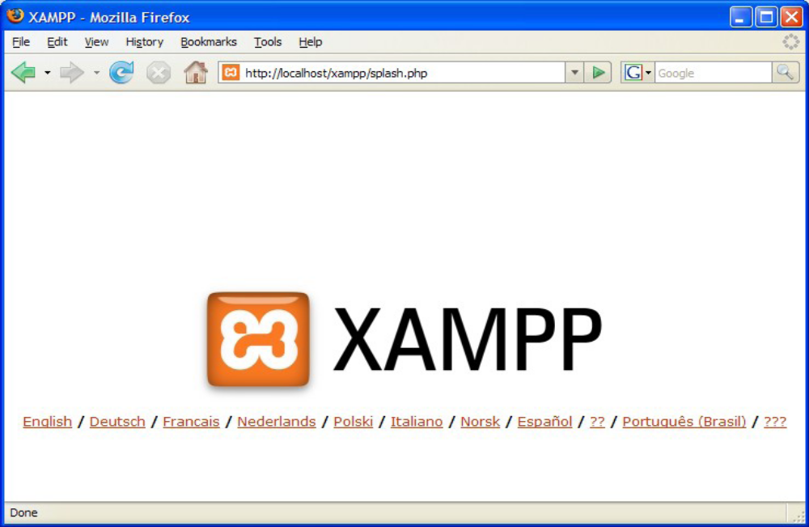XAMPP splash screen.

In order to stop all Apache processes we do not close the running terminal application, but instead run another batch file in the xampplite directory called apache_stop.bat.

7.6 Creating a Database and Inserting Data

Now that we have run and tested Apache and PHP, the next step is running MySQL and creating a database and table which will hold information to be used by our website. In order to start MySQL, navigate to the xampp directory and run the mysql_start.bat batch file.The XAMPP package contains an application called phpMyAdmin which allows developers to administer and maintain MySQL databases.We will be using phpMyAdmin to create a database and table, and enter test data. Before testing phpMyAdmin, make sure that both Apache and MySQL are running by opening their respective batch files: apache_start.bat and mysql_start.bat. Along with Apache and MySQL running in the background, we type http://localhost/phpMyAdmin/ into our web browser. If successful we will be presented with a phpMyAdmin start page similar to the one shown below.

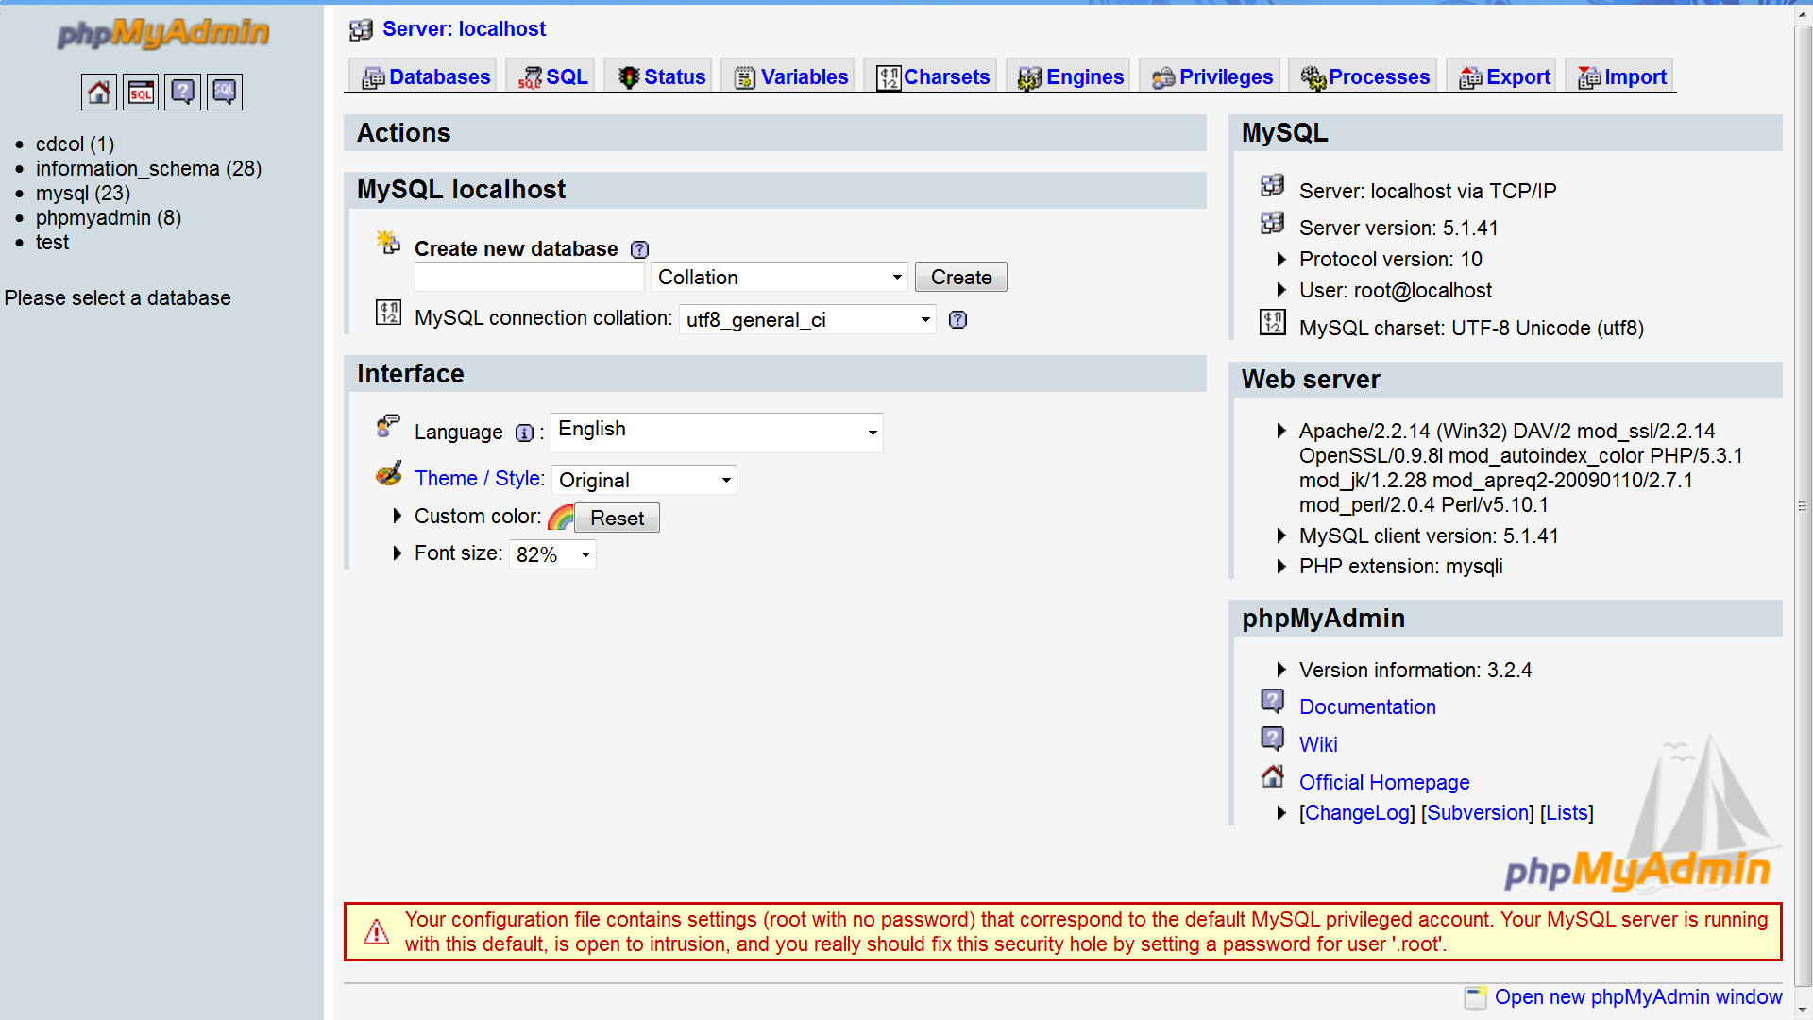
phpMyAdmin start page

The first step with phpMyAdmin running is creating a new database.We create a new database by directly executing SQL statements as shown below.The successful execution of the sql querry creates a database ‘student’ with two tables in it.The tabels are admin_login and student_information.We also inserted values in the admin table.The screenshot below shows the successful execution of the query thus creation of a database named student.

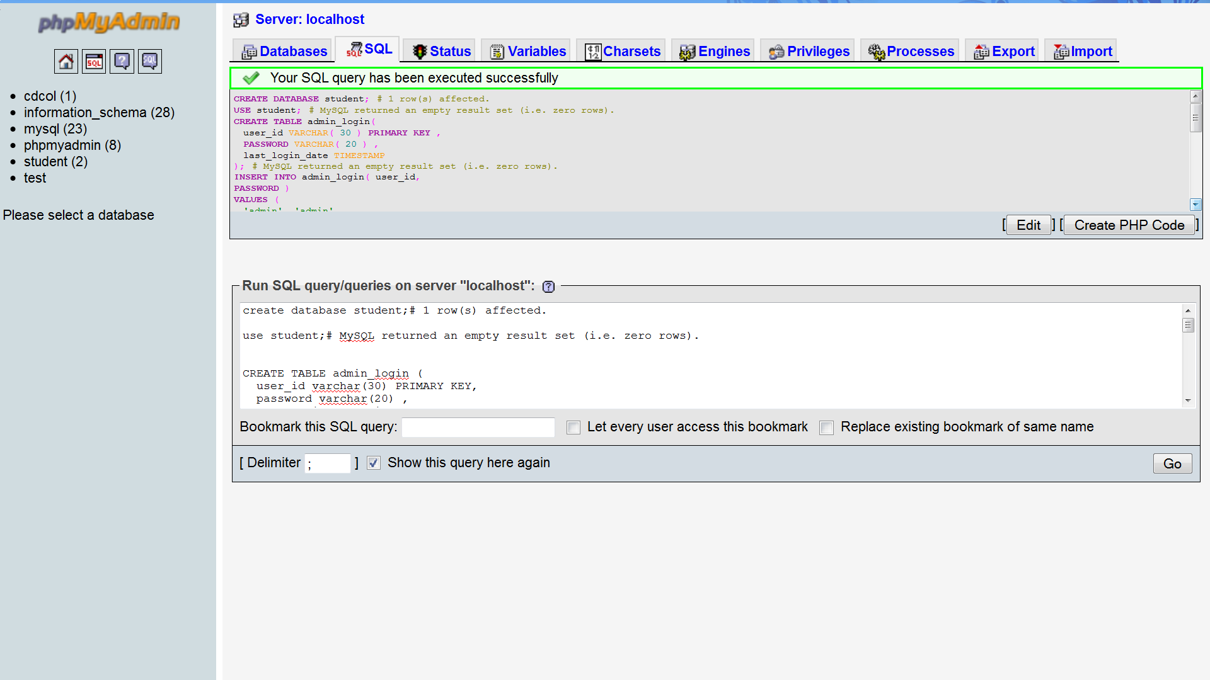
Creation of database in mysql using phpMyadmin

Thus we have learned to create a database in MYSQL by executing sql statements. After creating the database and tables we are now ready to use them in our website “Student Information Management System” .

8.PROJECT DESCRIPTION

8.1 Introduction
Student Information System can be used by education institutes to maintain the records of students easily. Achieving this objective is difficult using a manual system as the information is scattered, can be redundant and collecting relevant information may be very time consuming. All these problems are solved using this project

The directory structure of the project is as follows:
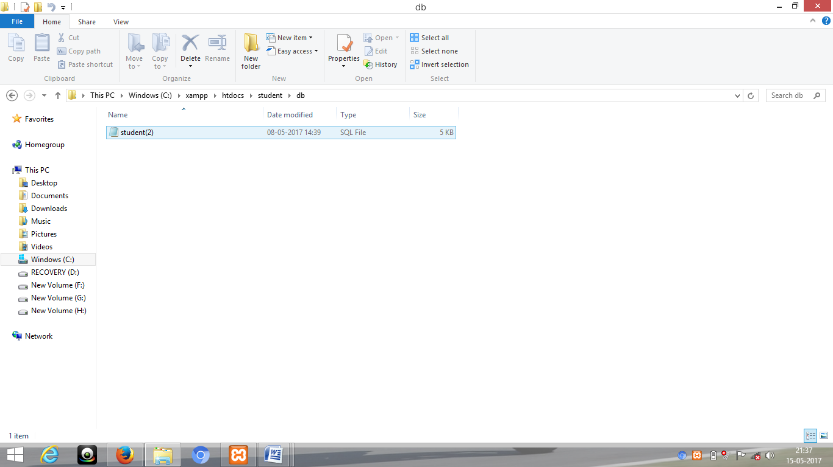.
8.2 Description of root directory contents
- Images Directory : This directory contains the images uploaded by the students during registration process.Supported formats are the .jpg and .gif files.
- Addadmin.php : Addadmin page for Adding New Admin here we can use multi admin..
- Addstudent.php: In this Page Admin can add student information for handling the Addstudent.php file. It writes the student information in the database on the server.
- Admin.php : click admin button to view the login page
- AdminLogin.php : Login page for administrator access.Shows appropriate message for wrong username and/or password.
- Adminmenu.php : Page handler for Adminmenu.php page.It shows the admin menu.
- Adminsection.php : Page to display administrator page.
- Adminview.php : Page for new admin database register.
- Attendance.php : Page to enter students attendance to the.This facility is only available to the administrator.
- Attendanceupdate.php : page to enter student updated attendance. This facility is only available to the administrator
- Connection.php : it is the connection with the database.
- contact.php :this page use to mail to the admin by a website user.
- Cu.php : this the page to write a contact base details under the box.
- Footer.php : footer file for the page
- Header.php : Header file for student pages.
- Index.php : Homepage of the website.
- Internal.php: this page enters the student marks details
- internalupdate.php : this page enters the student update marks details
- Searchcourse.php : Page to display searchcourse to the website user.
- Studentresult.php : Page to display student information for any selected search result.
- Studentdetails.php : Page to view/edit student information.It can be accessed by admin..
- Validation.php: Javascript validations used for validation of form values. Various form entries are validated at the client side using this file only.

8.3 Description of database tables

8.3.1 Admin_database
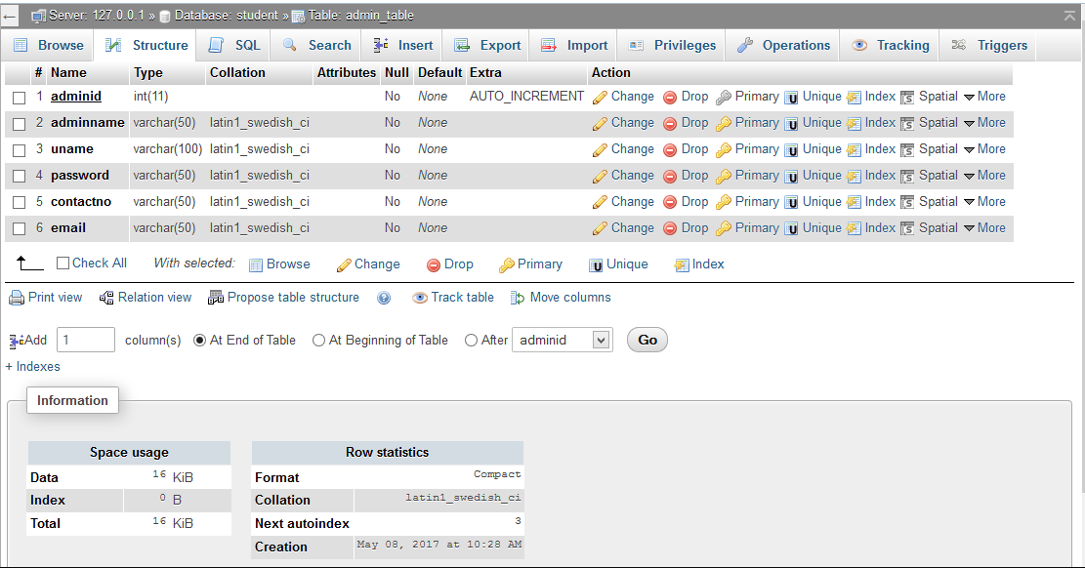

- admin_id : Stores admin id of administrator(s).
- adminname: stores admin name of the administrator(s)
- uname: stores the present user admin.
- password : Stores password of the administrator(s).
- contactno:it stores contact no of the administrator
- email: it stores mail id of the administrator

8.3.2 Student attendance database

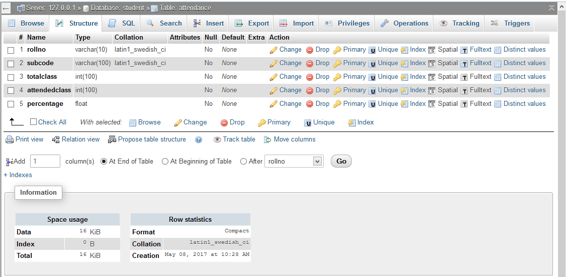`
  - Roll no : Stores Roll no of the student(s)
  - subcode : enter attendance by subject code of the student(s)
  - totalclass : total class taken during semister
  - attendedclass : total class attended by the student(s)
  - percentage: result of the attendance in percentage

8.3.3 Contact
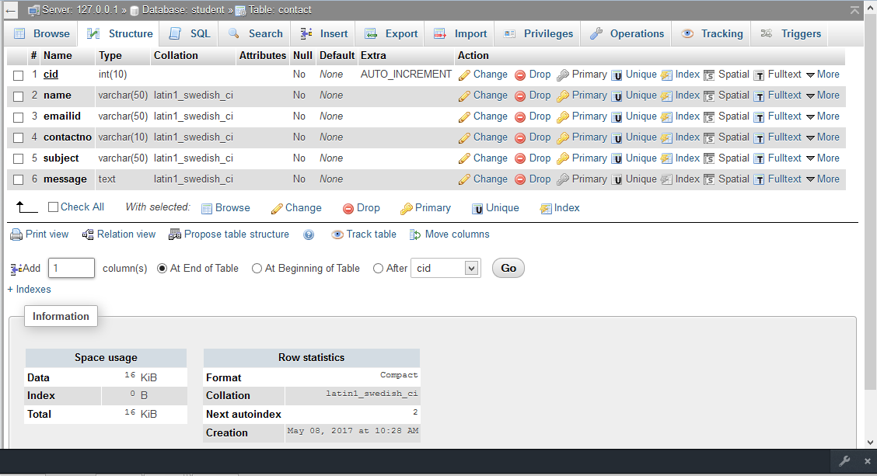

cid: it stores the contact id of the contact(s)
name: it stores the contact name of the contact(s)
emailid: it stores the mail id of the contact{s)
contactno: it stores the contact no of the contact(s)
subject: it stores the subject of the mail
message: it stores the message sent by the contact(s)

8.3.4 Database Internal

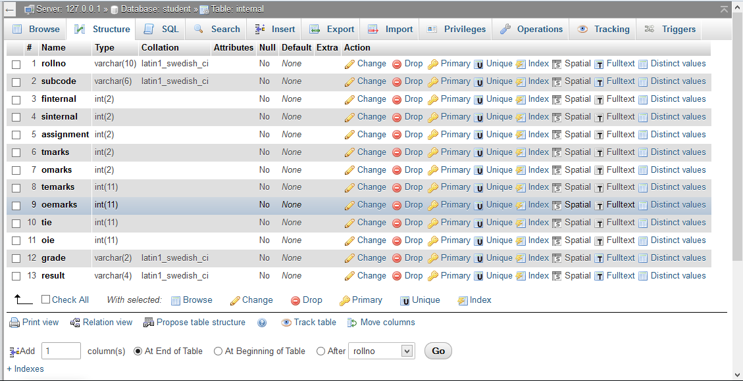
Roll no: it stores the student roll no
Subcode : it stores the subject code taken by the student.
finternal:it stores the first internal marks of the student(s).
sinternal:it stores the seconf internal marks of the student(s).
assignment: it stores the assignment marks of the student(s).
tmarks:it stores the total marks of the subject
omarks: it stores the obtained marks by the student(s)
temarks:it stores the total external marks of the subject.
Oemarks: it stores the obtained marks by the student(s).
Tie: it stores the total internal +external marks of the subject
Oie: it stores the total internal + external marks of the student(s).
Grade: it stores the grade obtained by the student in end semester.
Result: it stores the result record of the student(s).

8.3.5 Database Student_Info
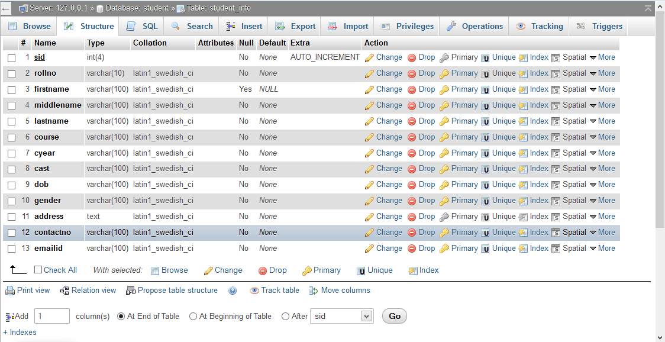

sid: it stores the student unique id
roll no: it stores the roll no of the student(s).
firstname : it stores the first name of the student(s).
middlename: it stores the middle name of the student(s).
lastname: it stores the last name of the student(s).
course: It stores the course taken by the student(s).
cyear: it stores the course year of the student(s).
cast: it stores the caste which belong by the student(s).
dob: it stores the date of birth of the student(s).
gender. It stores the gender of the student(s).
address.it stores the address of the student(s).
contactno: it stores the contact no of the student(s).

9. Features
The Website provides following functionalities to the users :
- Administrator :
- Login/Logout
- View student information
- Edit Student Information
- Enable/disable student accounts
- Search students

- Student :
- View homepage
- View result
- Contact admin through

10.SNAPSHOTS
10.1 Homepage
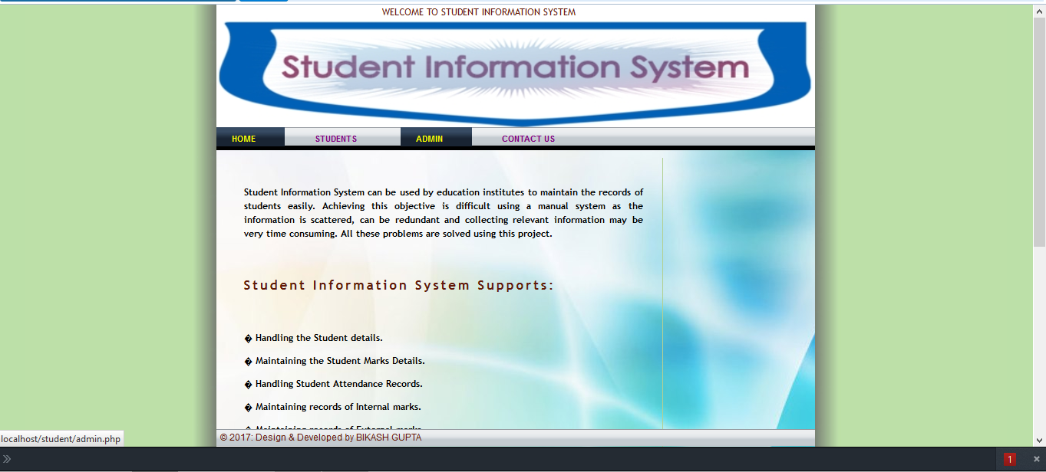
This is the homepage/indexpage of the site.

10.2 Student Page
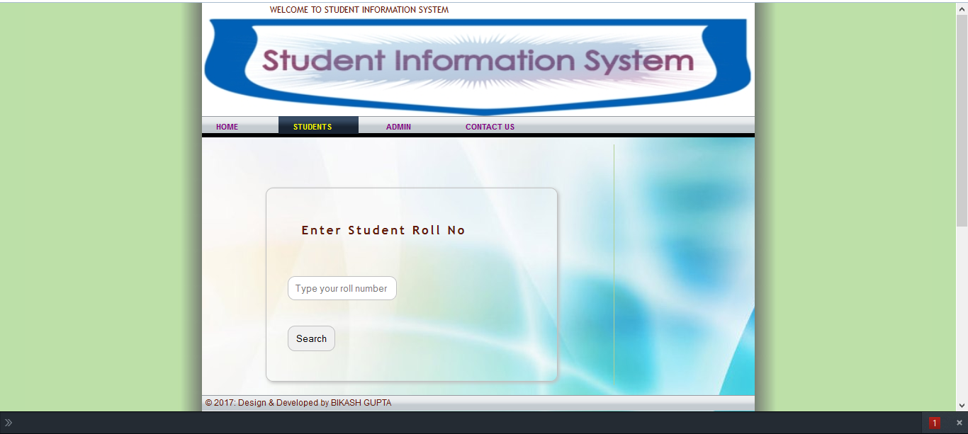
This is the student page.

10.3 Student View Page
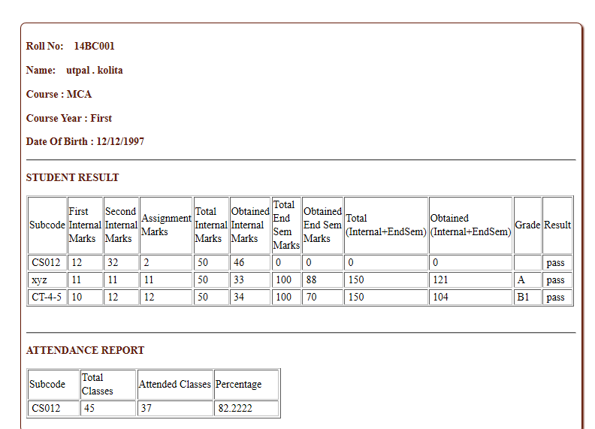
After enter his/her roll no of the student view page is opened as shown above.The student can view their result /and class attendance record.

10.4 Administrator Page

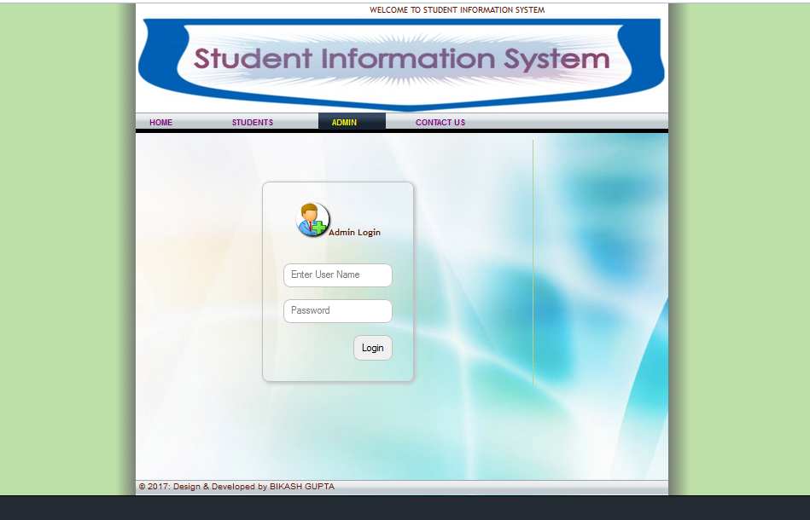
The above page is the administrator login page. It requires the administrator username and password.

10.5 Admin homepage

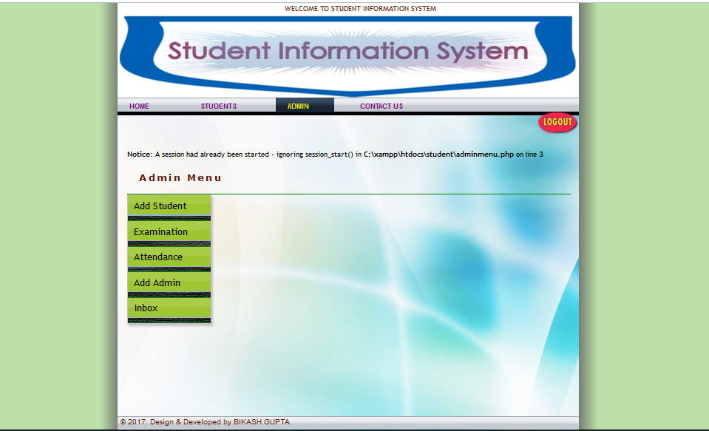
This is the homepage of administrator.

10.6 Student info Page
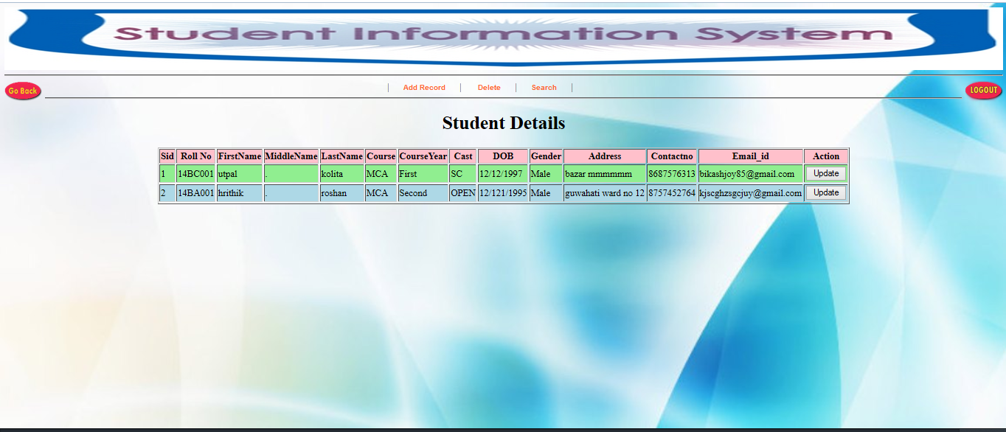
This is the display all page where the administrator can see all the students details .He can view/edit students information.
10.7 Student Search Page

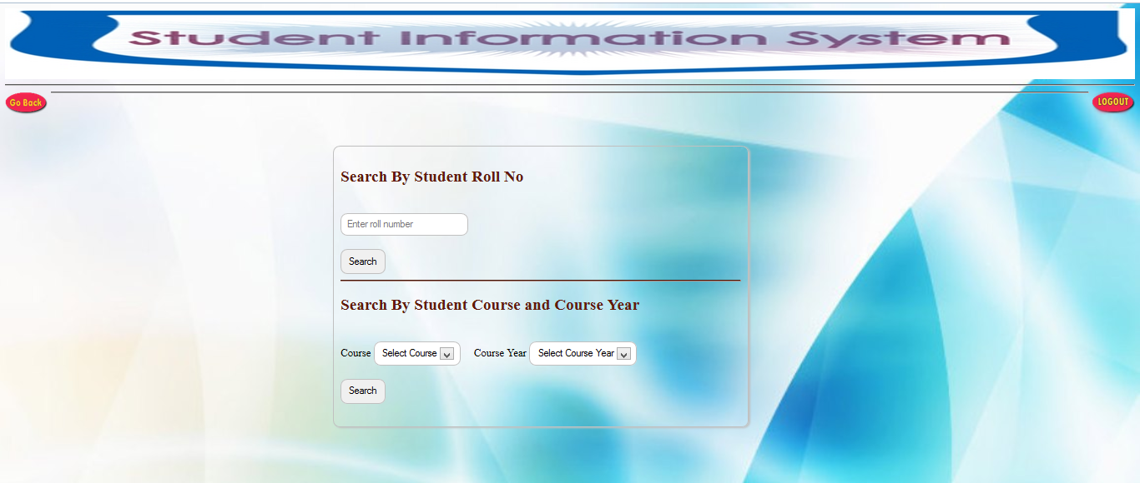
This is the search page and it provides search function to the administrator.here we search for all the students with theirs roll no/course/course year.
10.8 Search Display Page
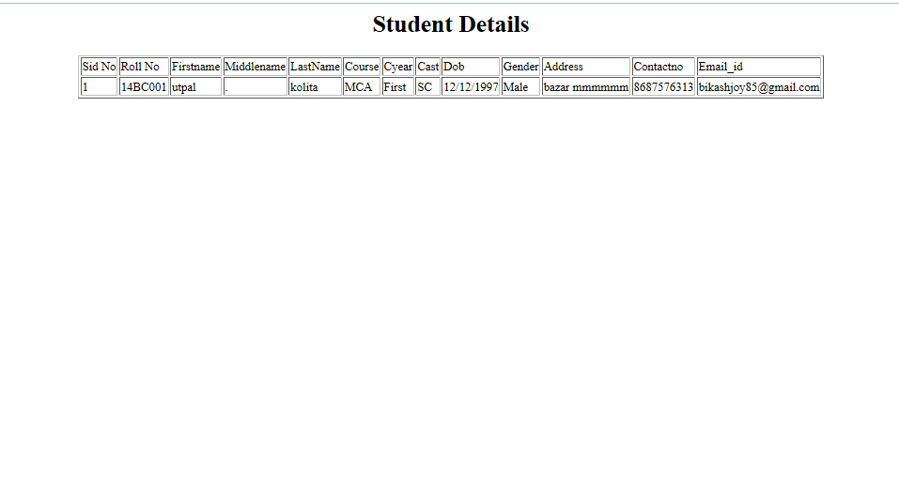
This is the search result display page.the administrator can view profile of any of the searched students from here.If there are no results then an appropriate error message is displayed.

11. FUTURE SCOPE OF THE PROJECT
- The Student Information System(SIS) can be enhanced to include some other functionality like marks,attendance management.
- Social networking can also be added wherein students can interact with each other.
- Online class functionality can be added.
- Can evolve as an online institution.
- Functionality of chat and messages can be added.
- Online exam functionality can be added.
- Online resume builder functionality can also be added.

12. Conclusion
The college can handle full-scale computer related resource. College administration system deals with all the activities done by computer such as registration and admission process, staff and class management, time etc all these process are handled by computer management system
13. CONTRIBUTION IN THE PROJECT
Student information system lead to a better organization structure since the information management of the students is well structured and also lead to better as well as efficient utilization of resources.

Student Information System can be used by education institutes to maintain the records of students easily. Achieving this objective is difficult using a manual system as the information is scattered, can be redundant and collecting relevant information may be very time consuming. All these problems are solved using this project

Our project Student Information System was developed by me . I took a step by step approach in order to reach my project goal. i applied the knowledge i gained during the class period at NORTH LAKHIMPUR COLLEGE and developed this project “STUDENT INFORMATION SYSTEM”.

14. Bibliography

- PHP PDF by Vasvani (TMH publications).
- Beginning PHP5 by WROX.
- www.google.com.
- www.wikipedia.com
- www.w3schools.com
- Head First PHP & MySQL by Lynn Beighley and Michael Morrison(O’Reilly)

